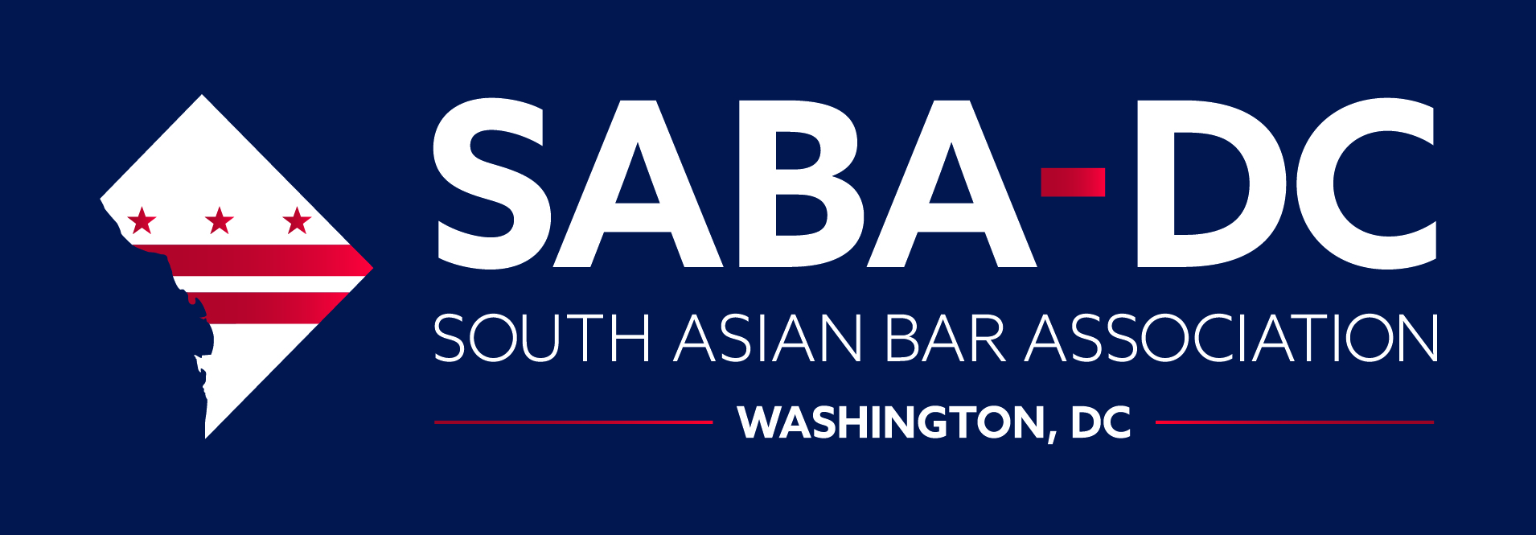
2021 Public Interest Fellowship Application

The South Asian Bar Association of Washington, D.C. seeks to organize, support and promote public interest activities and projects for the benefit of the South Asian community and the metropolitan D.C. area.
The South Asian Bar Association of Washington, D.C. strives to promote the professional development of South Asian lawyers and law students, educate the South Asian community about relevant legal issues, expand and enhance business and professional opportunities for South Asians, increase the participation of South Asians in civic affairs and government, facilitate the exchange of ideas and information to South Asians, and foster goodwill, fellowship, and unity among the South Asian community.

About SABA-DC Public Interest Fellowships
SABA-DC provides financial assistance in the form of summer fellowships to law students working at public interest organizations in the metropolitan D.C. area. The primary purpose of the fellowship is to help fund a student’s internship with a public interest organization for the benefit of the South Asian community and the metropolitan D.C. area. The number of Fellowships awarded, as well as the amount of each grant, will be determined by the SABA-DC Fellowship Committee and is based on SABA-DC’s fundraising efforts and the number of quality applicants it receives. SABA-DC has provided grants up to $7,500 per fellow in past years, and sponsors several fellows every year.
Fellowship Selection Criteria
Each applicant must be a current law student in good standing, and must have received confirmation of employment or internship with a public interest organization during the summer of 2021. Public interest law can be practiced in various settings to include: nonprofit organizations; legal services organizations; district attorneys'/public defenders' offices; federal, state, and local government; and public service law firms. SABA-DC considers all of the materials submitted by the applicant, with particular weight given to the applicant’s essay. In addition, SABA-DC will schedule interviews with applicants as part of the selection process. Other factors that SABA-DC may consider include commitment to public service, financial need, academic achievement, and other criteria. Fellows are expected to complete two short essays about their experience before the end of their fellowship and to attend at least three SABA-DC events during the summer of their fellowship. Fellows are also encouraged to attend the SABA-DC Public Interest Gala (due to COVID-19, this event may be virtual in 2021), typically held in October.
SABA-DC Non-Discrimination Policy
It is the policy of SABA-DC not to discriminate on the basis of age, gender, disability, race, color, creed, religion, ethnicity, national origin, veteran status, or sexual orientation. All potential applicants are encouraged to apply.
Fellowship Application Instructions
Applicants must submit the following materials: (1) completed application form, (2) essay responses, (3) resume with references, and (4) completed Employer form. Applicants may also submit the following optional materials: letters of recommendation, or evidence of financial need. Completed application materials must be e-mailed no later than April 12, 2021 to sabadcpifellowship@gmail.com.
One or more members of the Fellowship Committee will interview applicants beginning the week of April 19, 2021. All applicants will be notified of the Committee’s determinations by May 10, 2021.
SABA-DC reserves the right in its sole discretion to change the number of fellowships awarded, the dollar amount of each fellowship or not award any fellowships in 2021. Please direct questions to sabadcpifellowship@gmail.com.
The amount of the award shall be determined in the discretion of SABA-DC, taking into account relevant considerations including the length and nature of the internship. In the absence of demonstrated economic hardship or other extenuating circumstances, a recipient shall receive half of a fellowship award at the commencement of an internship and half with one month remaining in the internship. Upon conclusion of the internship, the recipient shall submit to SABA-DC a one-page written statement describing the services rendered by the recipient and the benefits afforded by the internship to the South Asian community.
A fellowship recipient must immediately notify SABA-DC in writing if the recipient (a) leaves the summer position listed in their application, (b) changes employers, (c) ceases to work for the required number of hours, or (d) becomes subject to academic discipline or ceases to be enrolled in law school. In its discretion SABA-DC shall determine whether forfeiture of the fellowship or a modification of the terms or amount of the award is appropriate. A recipient’s failure to comply with SABA-DC’s policies and/or the conditions of the fellowship may result in the forfeiture of the entire award or a portion thereof.

SABA-DC Public Interest Fellowship Application

1. Name of Applicant:
Law School:
Graduation Year:
Email Address:
School Address:
Permanent Address:
Telephone Number Day: Evening:
2. Essay Questions
(1” margins, Times New Roman size 12 pt. font, single spaced; please respond to the below three prompts in two pages or less)
Please describe the following:
a. How you have previously served and/or plan to serve the South Asian community in the D.C. community or your community? Your comments may also include why you believe public interest
work is important or relevant to the South Asian community.
b. The organization(s) you will be interning or employed with over the summer, the community they
serve, and what your duties will be.
c. The reason why you applied to the organization you will be interning for and how you believe this
experience will benefit you as a public interest attorney.
d. Please describe your immediate career and professional goals upon graduation.
e. Any additional information you would like the Fellowship Committee to consider.
3. Attach your resume with a minimum of two references.
- Submit a completed and signed SABA-DC Public Interest Fellowship Employer Form. (If more than one summer internship, supply one form for each internship.)
SABA-DC Public Interest Fellowship Application
Page 1

- Please identify below all other grants/scholarships/sources of funding for which you have applied and/or will be receiving during the period for which you seek a SABA-DC Fellowship (attach a supplemental sheet if needed). For status of application, please indicate whether it is pending or granted.
Grant/Scholarship/Source of Funding | Status of Application | Award Amount

6.

7.
(Optional) Please submit one digital photograph portrait for publication in the SABA-DC Newsletter.

(Optional) You may submit your most recent law school transcript, letters of recommendation, and/or evidence of financial need if you would like the Fellowship Committee to consider them.
I, the undersigned applicant, certify that all statements and information contained herein and in all application materials are true, correct and accurate to the best of my knowledge.
I, the undersigned applicant, understand that if I receive a SABA-DC Public Interest Fellowship and if (a) I cease to work for the number of hours set forth above, (b) the nature of the work changes materially, (c) I change or leave the internship, (d) I become subject to academic discipline or cease to be enrolled in law school, or (e) I receive funding for the internship that I had not previously identified in the application, I must immediately provide written notice of such event or condition to.
Print Name of Applicant Signature of Applicant Date
APPLICATION MATERIALS MUST BE E-MAILED NO LATER THAN April 12, 2021 TO sabadcpifellowship@gmail.com.
SABA-DC Public Interest Fellowship Application
Page 2
SABA-DC Public Interest Fellowship Employer Form
This form must be submitted, along with a letter from the prospective employer as detailed below, as part of the application for a South Asian Bar Association of Washington, D.C. Public Interest Fellowship. An employer, supervisor or professor under whose supervision the applicant will work during the period of the fellowship must complete this form.
Employer Name:
Employer Address:
Immediate Supervisor
and Immediate Supervisor’s
Telephone Number:
Is the Employer a Non-
Profit Organization? Yes: No:
To the prospective employer: On agency letterhead, please briefly describe (a) the type of position offered to the applicant, (b) the nature of the project or work to be performed by the applicant, (c) the start date of such project work, (d) the number of hours to be worked by the applicant, and (e) the length of time the applicant will be so employed or engaged.

I, the undersigned employer/representative of employer, certify that [Name of Applicant] will be working under my supervision and that all information contained herein is true, correct and accurate to the best of my knowledge.
Signature of Employer/Representative of Employer Date
Print Name of Employer/Representative of Employer

SABA-DC Public Interest Fellowship Application
Page 3

