Ms. Wilson is the Executive Director of the State Bar of California. In that capacity, she manages a $180 million budget and 550 staff who are responsible for regulation, licensing, and discipline of California attorneys, as well as for promoting access to legal services and inclusion in the legal profession. Prior to her appointment to that position in September, 2017, she served as the Chief Operating Officer for the State Bar.
Before joining the State Bar Ms. Wilson served as the Court Executive Officer (CEO) for the Alameda County Superior Court. There, in addition to being responsible for overall court operations, personnel, budget and policy, she took a particular interest in collaborative courts, and advocated for the use of risk assessment tools and an expansion of effective alternatives to incarceration.
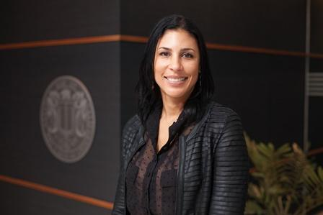
Ms. Wilson holds a Master’s Degree in Public Policy and a Juris Doctorate, both from the University of California, Berkeley, and is a member of the California State Bar. She also served as President of the Berkeley Unified School District’s Board of Education.

