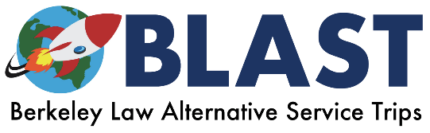

Berkeley Law Alternative Service Trips (BLAST)
2018-2019 Trip Descriptions

Deborah Schlosberg
Director, Pro Bono Program
Associate Director, Competitions Program
probono@law.berkeley.edu
510.664.4614

David Oppenheimer
Clinical Professor of Law
Faculty Co-Director, Pro Bono Program
doppenheimer@law.berkeley.edu
510.643.3225

Sue Schechter
Field Placement Program Director
Faculty Co-Director, Pro Bono Program
sschechter@law.berkeley.edu
510.643.7387

Table of Contents:

Kentucky……………………………………………………………………………………………………………………………………………… …………………3
Los Angeles……………………………………………………………………………………………………………………………………………………………..3
South Texas……………………………………………………………………………………………………………………………………………………………..3
Mississippi……………………………………………………………………………………………………………………………………………………………….4
Central Valley…………………………………………………………………………………………………………………………………………………………..4

KENTUCKY
This year, BLAST-Kentucky will send a group of eight students to eastern Kentucky to work with two partnering organizations: Appalachian Citizen’s Law Center and AppalReD Legal Aid.
AppalRed Team: Throughout the week, Group A will work with the Appalachian Research and Defense Fund of Kentucky (AppalReD) conducting a divorce clinic and helping with other traditional legal service projects.
Appalachian Citizen’s Law Center (ACLC): Throughout the week, Group B, will work with the ACLC helping file black-lung benefit claims and on other environmental and natural resources legal issues of Eastern Kentucky.

Time Commitment: In addition to the entirety of Spring Break 2019, we anticipate that trip participants will have monthly trainings/meetings with some social events throughout the school year. Trainings will likely be once a month in the 12:45-2:00 lunch slot. Students will be expected to participate in fundraising (events and online), but there is no required minimum amount that they have to raise. Dates and times of meetings are to be determined based on availability of participants.
For more information, please contact the student leaders at blast@law.berkeley.edu.

LOS ANGELES
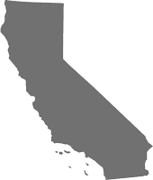
This will be the first year of BLAST’s Los Angeles service trip! This trip will focus on providing legal services to the homeless population in Los Angeles.
We will be partnering with two local legal, non-profit organizations: Inner City Law Center and Bet Tzedek. Students can expect to do substantive legal work and interact with members of the homelessness services community. We will be working closely with attorneys to understand and address the issues that the Los Angeles homeless population faces. In addition, members will have the opportunity to meet renowned community leaders and gain hands-on experience through community service. We expect members to be enthusiastic to work with and assist individuals experiencing homelessness.
We expect members to complete assigned readings before each meeting and contribute to group conversations. On occasion, we may have guest speakers who will provide more insight on the week’s topic.
Our goal is to ensure that members feel prepared to tackle pressing legal issues with enthusiasm, creativity, and sensitivity. Prior to the trip, members will have the opportunity to bond and become familiar with one another through our various social events. We will also do our part to share our love of Los Angeles!
Time Commitment: In addition to the entirety of Spring Break 2019, we anticipate that trip participants will have monthly trainings / meetings with some social events throughout the school year. Trainings will likely be once a month in the 12:45-2:00 lunch slot. Students will be expected to participate in fundraising (events, online, and others) but there is no required minimum amount that they have to raise.
For more information, please contact the student leaders at blast@law.berkeley.edu.

SOUTH TEXAS
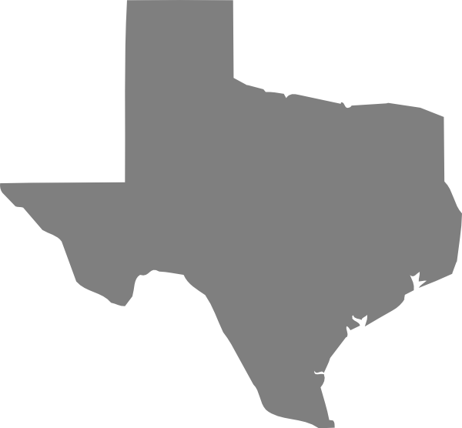
The largest immigrant family detention center is the South Texas Family Residential Center (STFRC) in Dilley, Texas, approximately 80 minutes southwest of San Antonio. Despite the Flores Settlement Agreement, which dictates that children cannot be held in a secure unlicensed facility, the government continues its inhumane detention of children and their mothers who have valid asylum claims under U.S. law. The Catholic Legal Immigration Network (CLINIC), the American Immigration Council (AIC), the Refugee Immigration Center for Education and Legal Services (RAICES), and the American Immigration Lawyers Association (AILA) joined forces to form the CARA Family Detention Project in response to ICE’s significant expansion of family detention. Texas RioGrande Legal Aid joined the effort to ensure asylum-seeking families have access to competent and effective legal services shortly thereafter and currently manages the provision of legal services in Dilley in partnership with CLINIC, AIC, and AILA.
To ensure asylum-seeking families have access to legal representation, participants will travel to Dilley during Spring Break. Participants commit to a Sunday through Friday work schedule with a mandatory on-the-ground training session taking place on Sunday evening. The training session begins at 5 p.m. in Dilley, Texas. The first working day will be Monday. Currently, the work includes completing client intakes, preparing clients for credible fear and reasonable fear interviews with the asylum office, accompanying clients to their asylum office interviews, and providing representation before the Immigration Judge in negative credible fear reviews and bond hearings.
Time Commitment: In addition to the entirety of Spring Break 2019, we anticipate that trip participants will attend a series of training sessions in the fall and spring semesters to learn more about asylum law and immigration law. Meeting times would depend on participants’ schedules but would likely take place during the lunch hour (12:45 p.m. to 2 p.m.).

For more information, please contact the student leaders at blast@law.berkeley.edu.

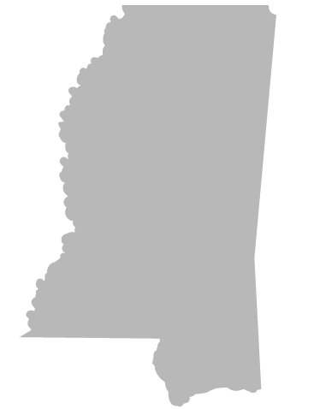
MISSISSIPPI
Law students will have the rare opportunity to work with the Mississippi Office of State Public Defender to access juvenile county courts, which are otherwise closed to the public. Students will observe juvenile proceedings and collect data regarding access to and quality of representation, and other due process concerns. Students will then analyze this data and may work after the trip to draft a report regarding the state of juvenile defense. The trip will also include a variety of activities exploring Mississippi’s unique history and culture, with a focus on civil rights.
Time Commitment: In addition to the entirety of Spring Break 2019, we anticipate that the trip participants will have monthly trainings/meetings with some social events throughout the school year. Trainings will likely be once a month in the 12:45-2:00 lunch slot. Students will be expected to participate in fundraising (events and online), but there is no required minimum amount that they have to raise.
In addition, students will have the option to continue working on the report summarizing our youth court findings after spring break. We anticipate that work should be completed in the weeks following the end of the Spring semester.
For more information, please contact the student leaders at blast@law.berkeley.edu.

CENTRAL VALLEY
The California Central Valley trip will expose students to the legal issues of communities so close to the Bay Area in which we live, but whose stories are often left untold. This trip will partner with two nonprofit organizations in the Central Valley. One of the organizations will be the Central California Legal Services, which provides legal aid to qualifying individuals below the poverty level. The second organization is still being determined. We expect to do a combination of direct legal services assistance with policy or legal research and writing work. The ability to speak Spanish is a plus, but is not required. In addition to providing legal assistance over spring break, students will meet with various entities in the Central Valley to learn more about the area and the work being done in the region.
Time Commitment: In addition to the entirety of Spring Break 2019, we anticipate that trip participants will meet 1-2 times a month to prepare for the trip, get to know the other group members, and learn about the Central Valley.
For more information, please contact the student leaders at blast@law.berkeley.edu.

