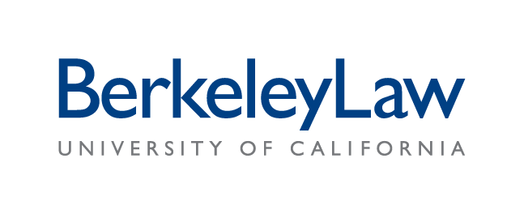Certificate of Attendance for California MCLE

Provider: University of California, Berkeley, School of Law Provider Number: 02442
Title of Activity: A Congress on Iceland’s Democracy
Date of Activity: Sat 03 Jun 2017
Time of Activity: 0900 to 1730
Location of Activity: Berkeley Law

TOTAL ELIGIBLE CALIFORNIA MCLE CREDIT HOURS: 3.25 hours

To Be Completed by the Attorney after Participation in the Above-Named Activity

By signing below, I certify that I participated in the activity described above and am entitled to claim the following California MCLE credit hours:

: 9-9:15 Intro / .25
: 11:15-Noon Module / .75
: 1-1:30pm Module / .5
: 3:45-4:15 Module / .5
: 4:15-4:45 Module / .5
: 4:45-5:30 Module / .75

: Total Hours

Print Your Name (clearly):

State Bar Number:

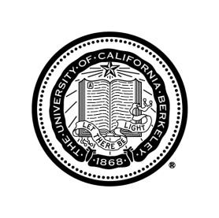
Signature:

