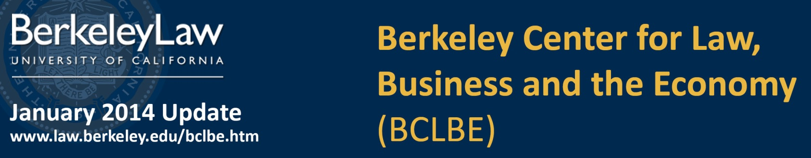
Connect with BCLBE:  │  │ 

Faculty News and Research Highlights  Private banks have been accused of taking on excessive risks, deceiving consumers and investors, and leaving taxpayers to foot the bill. The recent financial crisis and its aftermath have led some observers to ask whether we would be better off with a mix of public and private banks. Prof. Prasad Krishnamurthy discusses whether the Bank of North Dakota, a state-owned bank, could be taken as a model, and the implications it presents for the lending industry. Krishnamurthy believes that state-owned or public banks could play a useful role in stabilizing overall lending and mitigating some of the boom and bust cycle in credit markets. To read more go to the Daily Journal (registration required)  California has embarked on an aggressive path to reduce greenhouse gases through curbing the energy consumption of buildings. In September 2013, the CPUC issued a landmark rule allowing state public ratepayer funds to help finance energy efficiency improvements by building owners. One of the most innovative financing mechanisms authorized is a version of On-Bill Repayment financing (OBR) for single-family homeowners, allowing repayment of a private financial institution energy efficiency loan via the utility bill. To help California decision-makers, BCLBE Senior Fellow Lori Bamberger assembled the very first publicly detailed OBR Single-Family Financing Program Chart that compares operating decisions made in OR/WA, NY, KC, and SC.  BCLBE received a $116,983.80 cy près award to fund the launch of its Financial Literacy Education and Research Institute. The Institute will research, create, and implement consumer financial education programs that address the complex array of social, psychological, and economic factors that have historically limited efforts to improve consumer financial literacy. The cy près award stipulates that the funds be used for purposes including educating borrowers and promoting general financial literacy so borrowers and the public can better understand their rights and responsibilities. The award comes to BLCBE through the efforts of The Arns Law Firm. The diverse skills of the Berkeley Law faculty —including experts in financial institution regulation and operations, empirical psychological research, and effective disclosure document design – and the school’s close affiliation with the East Bay Community Law Center uniquely position the Institute for success. Read more>  Faculty News and Research Highlights [cont.]  Funded by a US State Department grant, BCLBE will undertake a survey that identifies obstacles to business and technological innovation in Russia. A joint collaboration with the Higher School of Economics, one of Russia's largest National Research Universities, the project aims to identify obstacles and lack of incentives in the current Russian Federation legislation that regulates innovation. Read more>  The Network Highlights  The Network blog provides the opportunity to academics, professionals and students to engage in dialogue about the impact of law and regulation on business and the economy. To submit posts and comments contact BCLBE .The following are recent selections:  Network Editor, Chris Hammond (J.D. Candidate ‘15) discusses the DC Circuit’s decision to overturn the FCC’s net neutrality order and take the internet into unchartered waters in which broadband carriers may use variable pricing models to charge more for companies that require faster download speeds or greater bandwidth. Read more>  The Dodd-Frank Progress Report, recently published by Davis Polk, reports in the past month, no rulemaking requirement deadlines passed, 36 rulemaking requirements were finalized and one rule was proposed that would meet a rulemaking requirement. The report also discusses a study issued by the FIO on ways to modernize and improve insurance regulation in the US. Click here to download the report>  As banks structure deals to circumvent the Federal Reserve System’s new liquidity coverage ratio proposal (LCR), regulators scramble to protect the financial industry from another fiscal meltdown. The LCR compels banks to maintain a liquidity amount equal to their projected cash flows minus the projected cash inflows. To meet this requirement, banks have been forced to cut their borrowing and are funding their operations using equity raised by the sale of shares. Consequently, the profit-making ability of the banks has been limited. Read more>  Skadden’s latest Transaction Advisers: Amendments to Delaware Law to Facilitate Short-Form Mergers in Two-Step Transactions, explains how acquisitions often employ a two-step structure in which the acquiror first launches a tender or exchange offer for any and all outstanding shares. Read the Advisory>  Sponsors   |  | Upcoming Lectures  Systemic Risk and the Financial Crisis:  Protecting the Financial System as a “System”  Steven L. Schwarcz, Duke University School of Law  Tuesday, February 25│Boalt 100 │12:45 – 1:45 pm  How should the law help to control systemic risk—the risk that the failure of financial markets or firms harms the real economy by increasing the cost of capital or decreasing its availability. Many regulatory responses to systemic risk, like the Dodd-Frank Act in the United States, consist largely of politically motivated reactions to the global financial crisis, looking for wrongdoers (whether or not they exist). But those responses are misguided if they don’t address the reality of systemic risk. Read more>  Curriculum Highlights  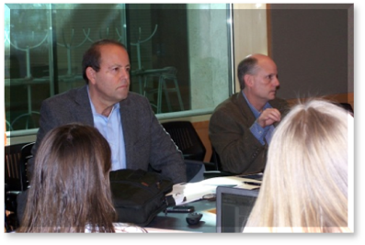  Early this month, students had the unique opportunity to gain insight into practical aspects of mergers and acquisitions transactions through the course Real World M&A.  This intensive four-day course was co-taught by prominent M&A attorney, Richard E. Climan, a partner at the Silicon Valley office of Weil, Gotshal & Manges, and Chancellor Leo E. Strine of the Delaware Court of Chancery who was recently nominated to serve as the eighth Chief Justice of the Delaware Supreme Court.  Class sessions were structured to lead students through deal dynamics by applying substantive knowledge from prior corporation law and M&A courses in the context of hypothetical situations derived from real world cases. In class assignments and discussions, students played the roles of investment bankers or lawyers providing advice to a client under real-life time pressures while learning from Mr. Climan’s and Judge Strine’s practical experiences and perspectives. [cont. on page 2]  Curriculum Highlights [cont.]  Real World M&A [cont.]  The course is expected to be offered on a yearly basis and presents an invaluable resource for any student wishing to complement their academic studies by experiencing M&A transactions from a practical perspective.  Students reported that they felt privileged to learn about real M&A deal making from Mr. Climan and Judge Strine. Ana Amodaj, J.D. Candidate ’14, said “The course emphasized the importance of the human dimension in negotiation and business operations, an element that is often overlooked in the academic setting.” Jose Bellagamba, LL.M. Student from Chile, added “This course is probably the best and easiest approach that a law student might have to feeling and understanding what M&A is all about, and how it's dealt with by the world's most important players. “One of my favorite parts of the class was listening to and watching such legal heavyweights have a conversation with two investment bankers about the role of the financial advisor in M&A deals," Meredith Pressfield, J.D. Candidate ’14 enthusiastically noted.  A great opportunity for Berkeley Law and Haas students to participate in a joint venture financing, structuring and drafting competition. The competition entails students being given a complex joint venture financing and structuring hypothetical case and being required to prepare a memo that responds to very specific questions that, to answer, requires the students to explore and understand the strategic, control and economic consequences of different joint venture structuring options. Details and sign-up information (first-come, first served) are here.  To address real-world and pressing legal issues, Berkeley Law added seven new courses this semester, including Social Enterprise Law, the brainchild of Professor Eric Talley, taught by attorneys Jordan Breslow and Susan Mac Cormac. Students will learn about the legal, regulatory, and business aspects of social entrepreneur entities, the structures that regulate them, and the types of available financing models.  Job Opening  BCLBE is currently looking for an Associate Director of Corporate & Foundation Relations to work closely with the BCLBE Executive Director and the Berkeley Law development team to secure grants and gifts to support BCLBE’s research, education, and policy activities. This is an exciting opportunity to join a dynamic team at Berkeley Law. Go to Berkeley Jobs and search #16419.  BCLBE Directors  Ken Taymor, Executive Director  ktaymor@law.berkeley.edu  Eric Talley, Faculty Co-Director  etalley@law.berkeley.edu  Nancy Wallace, Faculty Co-Director  wallace@haas.berkeley.edu  Contact BCLBE at: bclbe@law.berkeley.edu

