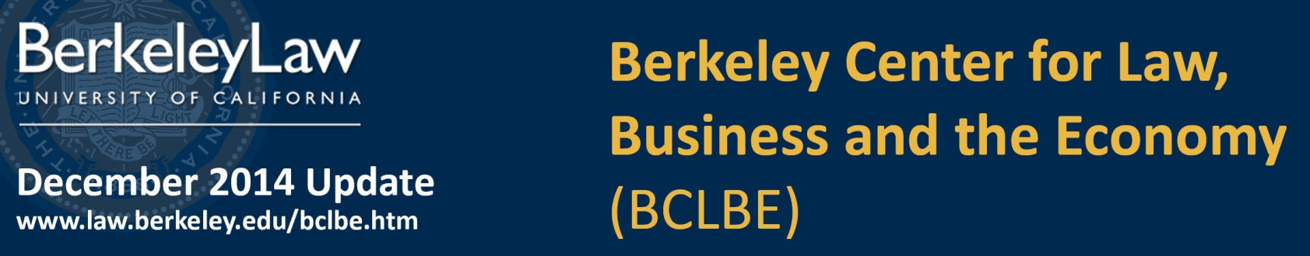
Connect with BCLBE:  │  │ 

Faculty News and Research Highlights  On November 14-15, Berkeley Law faculty, including Prof. Ken Ayotte, hosted the Fourth Annual Law and Economics Theory Conference. Economic theory can help shed light on important legal and policy questions that involve strategic actions by parties with interrelated and sometimes competing objectives. For example, firms often require employees to sign covenants not to compete (CNCs), which limit a worker’s ability to move to a rival firm or start his/her own. These covenants are common in high tech industries, but they are increasingly found in more surprising places, like the employee contracts of the sandwich chain Jimmy John’s. Should the law place restrictions on the enforceability of these covenants? Read more>  In the column The Deal Professor, Prof. Steven Davidoff Solomon discusses the influence and long reach of the Delaware courts in today’s global business environment, and the most prominent decisions that embody the court’s philosophy. He also talks about what “poison put” means following a recent judicial decision. Read more>  While affirmative action may stigmatize students from disadvantaged groups, Profs. Prasad Krishnamurthy and Aaron Edlin say group-blind admissions is not the remedy. Erasing social inequality-based stereotypes, their paper argues, would perversely require a higher admission standard for marginalized students. Download paper>  Curriculum Highlights  William Hinman will teach U.S. Securities Regulation of Non-U.S. Issuers in Spring 2015. Non-US companies are increasingly looking to the United States as a source of capital and liquidity. These companies range from internet giants such as Alibaba to small, privately held entities. This course will allow students to become well versed in the regulatory framework that applies to foreign issuers raising funds in the US, through both public and private offerings of securities. [cont. on page 2]  Curriculum Highlights [cont.]  U.S. Securities Regulation of Non-U.S. Issuers—It will cover topics including the periodic disclosure required of an issuer whose shares trade in the United States, the reach abroad of nationally based anti-fraud regimes, tender offers across national lines and the accounting issues that arise in global offerings.  William Hinman is a partner in Simpson Thacher's Corporate Department (Palo Alto), where his practice focuses on corporate finance, advising both issuers and underwriters in capital-raising transactions and corporate acquisitions. He has been involved in a number of significant initial public offerings, including the IPOs of Alibaba, Facebook, and Google.  Spring 2015 Joint Venture Structuring Competition  BCLBE, with support from the law firm of Pircher, Nichols & Meeks will be hosting our annual joint venture financing, structuring and drafting competition at the beginning of the Spring semester. The competition allows Berkeley Law and Haas business students to work together on teams that evaluate a complex joint venture financing and structuring hypothetical case. The student teams prepare a memo that responds to very specific questions that requires the students to explore and understand the strategic, control and economic consequences of different joint venture structuring options.  For details and sign-up information, contact BCLBE@law.berkeley.edu.  BCLBE Directors  Ken Taymor, Executive Director  ktaymor@law.berkeley.edu  Robert P. Bartlett III, Faculty Co-Director  rbartlett@law.berkeley.edu  Nancy Wallace, Faculty Co-Director  wallace@haas.berkeley.edu  Contact BCLBE at: bclbe@law.berkeley.edu  Sponsors  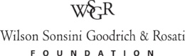 |  | Event Recap  Women in Business Law Speaker Series  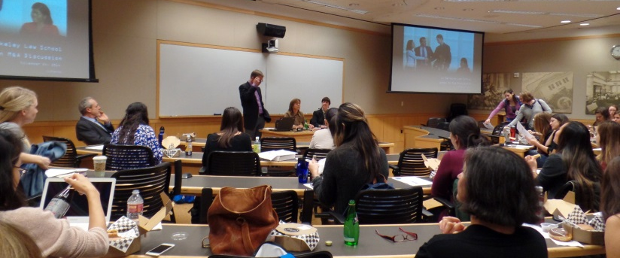  On November 24, Diane Frankle of Kaye Scholer LLP, Jennifer Muller of Houlihan Lokey, and Prof. Eric Talley, presented a recent study that confirms anecdotal reports that a wide gender gap persists in law firm M&A practices. Frankle and Muller, both accomplished experts in M&A and financial analysis, discussed what M&A lawyers do, strategies law schools and law firms can take to generate more interest in M&A, and how students and young lawyers can succeed in the field. This lecture was co-sponsored by the Boalt Hall Women's Association. Check out the video recording> and the photo gallery>  Spring Semester 2015 Lectures and Events Highlights  BCLBE has an extensive line-up of speakers, conferences and other programs for the Spring 2015 semester. Our speaker series topics include: M&A, Private Equity, Venture Capital, Shareholder Activism, and Women in Business Law. We will be hosting two large M&A Conferences and co-sponsoring the Berkeley Business Law Journal’s annual Business and Law Symposium. Some of the semester’s highlights include the following:  M&A Speaker Series  The View from New York  Thursday, January 22│ Boalt Hall 100 │ 12:45 – 1:45 pm REGISTER>  Expert M&A attorneys, Ethan Klingsberg, George Cary, Paul Shim and Benet O'Reilly of Cleary Gottlieb Steen & Hamilton LLP, will give New York perspective on M&A practice and review some of the newest developments in the field.  Next Semester Lectures and Events Highlights [cont.]  M&A and Antitrust Annual Conference  Antitrust, Governance, M&A in 2015—Challenges and Conundrums for the West Coast  Friday, January 23│ California Memorial Stadium, Berkeley  By invitation only  This conference, co-sponsored by Cleary Gottlieb Steen & Hamilton LLP, will be divided into two panel discussions: M&A and Antitrust. Panelists will discuss current issues and developments in these fields in a format designed to have broad interaction with leading practitioners and other special guests. Key speakers will include: Vice Chancellor J. Travis Laster, Delaware Chancery Court; David Gelfand, Deputy Assistant Attorney General in the Antitrust Division in charge of Litigation, U.S. Department of Justice; Marie Oh Huber, SVP, GC and Secretary of Agilent technologies; and Ann Mao, SVP, M&A at McKesson Corporation. For further information, contact BCLBE@law.berkeley.edu.  Venture Capital Speaker Series  A conversation with Ted Wang, Fenwick & West LLP  Monday, January 26│ Boalt Hall 170 (Koret) │ 12:45 – 1:45 pm  REGISTER>  Ted Wang represents emerging companies, venture capitalists, venture backed company CEOs and investment banks involved in a wide range of technologies with a focus on consumer Internet, e-commerce and software sectors. His practice ranges from the formation of new start-up companies through venture capital financings to public offerings, with a particular emphasis on mergers and acquisitions. Ted is a leader in efforts to standardize financing documents and is the curator of the Series Seed Documents.  Women in Business Law Speakers Series (February 23)  Amy S. Park of Skadden, Arps, Slate, Meagher & Flom LLP and Doreen E. Lilienfeld of Shearman & Sterling LLP will discuss the innovative programs that their law firms have developed to recruit, retain and promote women in various business law related practices.  Kirkland & Ellis M&A Roundtable (May 18-19)  BCLBE’s inaugural New York City program will feature a group of renowned thought leaders from industry, law firms, investment banks, private equity firms, hedge funds, academia and government in a frank and spirited discussion about leading M&A issues of the day.  Details on these events will be available in the next issue(s) of the Update and on our website soon.  If you would like to receive email notices and updates of our activities and publications, please join our email list>

