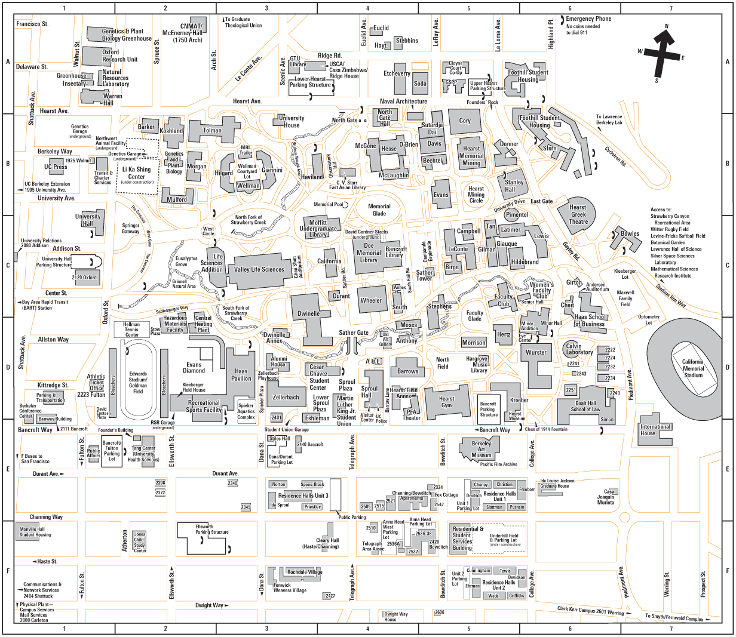

Anna Head Parking Lot: enter on Channing Way

Underhill Parking Structure: enter on Channing Way or Haste Street

Unit 3 Parking Structure: enter on Durant Avenue or Channing Way

Underground Parking: enter on Bancroft Way or Bowditch Street

Student Union Parking: enter on Bancroft Way

Bancroft Parking Structure: enter on Bancroft Way