277W Patent Law

Instructor in Charge: Professor Merges
Time Allowed: 24-hours

Take-Home Instructions: You have 24 hours within which to complete this exam. For the exam to be considered timely, you must upload your answers within 24 hours of downloading the questions.

Type your exam number, course name, page number and instructor’s name on each page of your typed answers. Answers must be typed and should be double-spaced.

Special Instructions:

- You my consult only your casebook and notes. Do your own work, no collaboration with others.

- There is 1 question on 11 pages. Be sure your copy of the exam contains all 10 pages.

- Thanks for a great semester. Enjoy your summer!

***********

Page 1 of 11

Question

Sandy Coolfacts (SC) works as a consultant to the Nevada Atlantic Lumber Co. (NAL), a large ($10 billion in revenues per year) forestry products and lumber company based in Maine. SC herself lives in California, but works at various NAL research labs in Maine, Oregon, and other states. One of NAL’s biggest selling items is lumber for making wooden decks. SC was put in charge of a group of consultants and NAL employees brought together to work on new wood decking products. SC’s project team was asked by NAL management to come up with a new and more “user friendly” type of deck planking that would set NAL apart from the competition. So beginning in September of 1997, SC’s team experimented with a number of different features of planking boards. Among the features they discussed in meetings were different surface curvatures to the boards they were working with. They wanted to find a way to extend the average life of a wooden deck (which is roughly fifteen years), and if possible make the deck more comfortable. They speculated that with a standard “5 by 4” decking board, measuring 5 inches wide 1.5 inches thick, curving or arching the top surface allowed the board to shed water more easily, which gave the boards a longer useful life by slowing the rate of water-assisted wood rot typical of wooden decks. The following diagram gives a general sense of what they discussed. The curved top surface is shown by the “a” on the right side of the diagram, which shows the amount of wood that was shaved off the top surface of the board to make it curved:

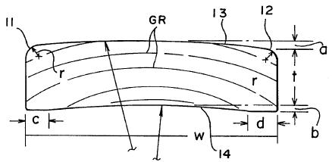

A more precise view of the SC team’s ideas is provided in Figure 2, below, which was sketched in SC’s project lab notebook on November 11, 1997:

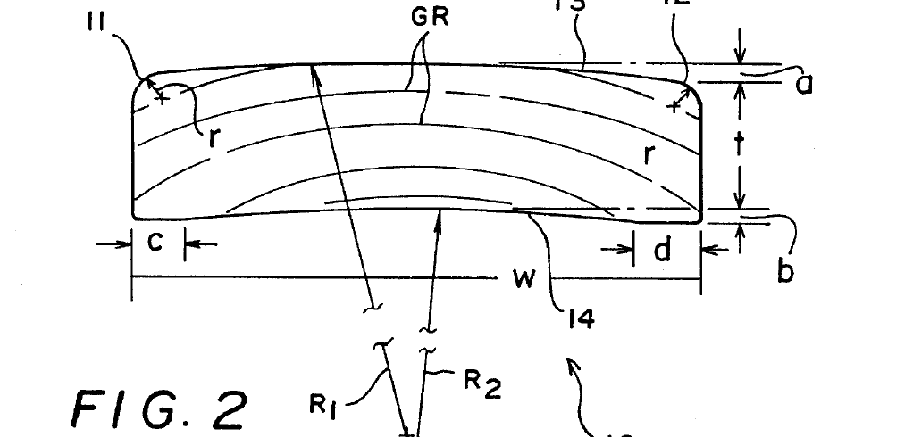

In this figure, you can see one of the key features of the invention. Look at the line labeled “R₁”. This line is known as the “radius of curvature” of the board depicted in Figure 2. The radius of curvature is the radius of an imaginary circle which includes the convex (curved) board. If you think of the bottom of line “R₁” as the center of the imaginary circle, you can see that as the circle gets bigger, the radius “R₁” gets bigger. (If that does not seem intuitive, sketch a few circles on a piece of paper. The larger circles have a longer radius; a smaller, “tighter” circle has a shorter radius.)

Beginning in early January, 1998, the SC team began actual experiments. In working with decking boards, the SC team found that a curved or arched board with a radius of curvature of 24 inches in a standard 5 x 4 decking board gave the best results: boards with these dimensions shed water quite well, but still feel comfortable to walk on. After a few additional experiments with different radii of curvature, and after testing their idea with “test subjects” hired to walk on decks built with curved boards, NAL management hired a patent lawyer to draft a patent application on the SC team’s idea. The lawyer drafted an application and filed it with the USPTO on May 16, 1998, naming SC and two other team members as inventors. (Several other team members who participated in the project have since moved on to other jobs.)

As the specification of the patent application states:

The claimed invention herein described presents a smoother and easier surface to walk on. It may also be useful in that boards manufactured as described herein may be easier to stack, and may make more efficient use of the round logs from which lumber stock is cut.

Example 1: Standard 5 x 4 decking boards with a radius of curvature measuring 18 inches were produced. They were assembled into an experimental deck measuring 20 feet by 20 feet. The boards showed good water-shedding properties. But thirteen out of fifteen experimental subjects exposed to such boards stated in interviews that the boards were not comfortable to walk on. They were described as “pointy,” “too arched,” and “uneven.” A separate group of boards was produced, having a radius of curvature of 24 inches; they were assembled into a 20 foot by 20 foot deck. These also showed good water-shedding properties in tests. And fifteen out of fifteen test subjects reported that the deck was “comfortable” or “fine.” A 24 inch radius of curvature is therefore found to be optimal for the herein described invention.

Some of the boards used in the example also had single or double grooves cut in the bottom, to facilitate flexing of the boards. Some also had arched surfaces cut in the bottom to further facilitate flexing.

Because decking boards are capable of being manufactured in other widths, however, the invention described herein is not limited to boards with approximately a 24 inch radius of curvature; other measures may also be adequate, depending on the width of the decking boards chosen.

Nothing in this description is meant to limit the scope of the claimed invention in any way. The invention described herein may be used with wood for applications other than decks, may be used with building materials other than wood, and may vary in other particulars as well.

Claims 1 and 2 as originally filed by NAL reads as follows:

- A board for use in constructing a flooring surface for exterior use, said board having a top surface, a bottom surface and opposite side edges, said top surface being manufactured to have slightly rounded or curved configuration from a longitudinal center line thereof downwardly toward each side edge, thereby defining a convex top surface which sheds water.
- A board according to claim 1, wherein said bottom surface has at least one groove cut into it length-wise, to make said board more flexible when force is applied to said top surface.

The patent examiner assigned to the case sent a rejection of this claim several months later. The examiner’s letter stated:

Claim 1 is rejected under 35 USC 102 in light of Erskine and under 35 USC 103 in light of Zimmer in combination with Erskine.

Claim 2 is rejected in light of Snider.

The Erskine reference is an illustration in a book by Carla Erskin entitled “Practical Woodworking Techniques,” published in London in 1924. Below is Figure 2 from Chapter 7 of the book, entitled “Outdoor Planking and Fencing Techniques”:

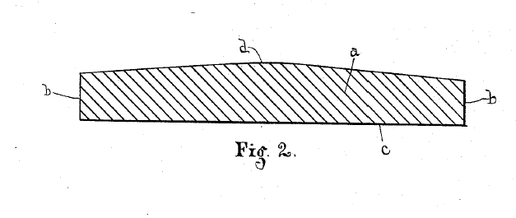

The text accompanying Figure 2 in the Erskine book describes how to “shave” or “plane” normal flat planks so they have a “small peak in the center, which tends to shed water and dirt and adds to the longevity of the wood.” The book goes on to say that the shaving and planing so described should be done with a flat blade or scraping tool, meaning that the “peak in the center” is formed by two flat planes running the length of the board. In other words, the top of the board is not circular or arched.

Below is Figure 1 from US Patent 919069 issued to Donna Zimmer in 1898 (the Zimmer reference referred to by SC’s patent examiner), entitled “Curved Paving Stones for Streets”:

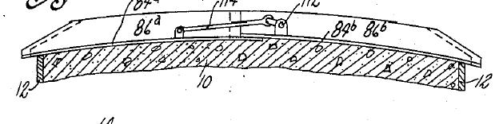

The Snider reference is a pamphlet from the Tree Institute, published in December, 1997. It describes woodworking techniques for restoring old houses. One passage deals with replacing old wooden floors laid over the top of aging linoleum, stone, concrete and other uneven surfaces. It recommends using a woodworking tool called a “rounter” to cut one or more grooves in the bottom of wood strips to be used for flooring. This will “make the floor more flexible, and lessen the feeling that it is uneven because of the uneven surface it is laid over.”

SC’s patent lawyer responded by “traversing” the rejections in the examiner’s letter, making the following argument in a letter sent to the patent examiner in April, 1998:

It is submitted that the Erskine reference discloses a non-flat plank with a generally “triangular” cross section; it is not arched, or circular, as the instant claimed invention [i.e., SC’s invention] is. Therefore the Erskine reference does not read on the “rounded or curved” limitation in applicant’s claim 1. We respectfully request that the rejection be withdrawn.

In addition, we submit that the Zimmer reference is not pertinent to the invention claimed herein in claim 1 [i.e., SC’s invention] because it is not drawn from the same technological field as applicant’s – pavement and stones being completely distinct from the applicant’s art of woodworking and forestry products. And, insofar as the Zimmer reference is pertinent, there is no suggestion or motivation to combine the water-shedding feature of Erskine with the circular or arched shape of Zimmer. Therefore under relevant Federal Circuit legal authority the rejection of claim 1 under 35 USC 103 is respectfully submitted to be inappropriate.

It is respectfully submitted that claim 2 is patentable over the Snider reference, because the invention date for the invention claimed herein predates the effective date of Snider. A Rule 131 affidavit is attached hereto, signed by each of the named inventors; it attests to the conception date for the invention recited in claim 2 and shows that this preceded the effective date of the Snider reference.

The examiner in turn responded by making the rejection final, meaning that he did not accept SC’s argument on these points. The examiner noted specifically that the Rule 131 affidavit was inadequate because several paragraphs mentioned members of the SC team who were not included as named inventors in the patent application filed by NAL. Rather than file a revised affidavit, or a continuation or an appeal, SC decided to abandon claim 2 (because the groove feature was deemed less important, and not worth fighting over on NAL’s limited patent department budget), and amend claim 1. The newly amended claim 1, and new claim 2, read as follows (additions are signified by underlines):

- A board for use in constructing a flooring surface for exterior use, said board having a top surface, a bottom surface and opposite side edges, said top surface being manufactured to have slightly rounded or curved configuration from a longitudinal center line thereof downwardly toward each side edge, thereby defining a convex top surface which sheds water and at the same time is comfortable to walk on, and said bottom surface having a concave configuration for nesting engagement with the top surface of another board so that a plurality of the boards may be stacked one on top of the other with the stability of conventional boards having flat top and bottom surfaces.
- A board of claim 1 wherein the ratio of the radius of curvature of said convex top surface of said board to the width of said board is approximately 5:1.

The examiner acquiesced in these changes to the application, and US Patent 5,999,055 (the ‘055 patent) was issued to NAL on July 25, 1999. Just prior to issuance, NAL’s lawyers filed a continuation of the original application, which means that the original specification and the revised claim were carried over into a new application which continued to be pending even though the ‘055 patent had issued.

Alston and Louis Lumber, Inc. (ALL) competes with NAL in the decking market. ALL sells both conventional wood planks, and a new type of planking manufactured from its own patented “composite” material – a light, porous plastic that is very strong yet flexible, much like wood. ALL calls its planking material “Plasti-Wood,” which it developed and patented in 1997. (The patent covers the composition and process for making Plasti-Wood, and is not limited to planking. It says nothing about the shape of boards made with the composition, but does mention that an advantage of Plasti-Wood is that it is easier to shape objects made with it than to cut sawn timber; “for example,” it states, “forming grooves in PlastiWood requires only a simple modification in the mold that forms the object, whereas cutting a groove in wood requires special tools such as a router.”

One of the innovative features of ALL’s Plasti-Wood is that it is more resilient and flexible than real wood. Because of this, ALL makes its Plasti-Wood outdoor flooring planks with a more circular cross-section than NAL’s. Thus the “radius of curvature” of ALL’s planks is lower than NAL’s – about 20 inches, compared to NAL’s 24 inches. Nevertheless, test subjects and customers report that ALL’s planks are not uncomfortable to walk on, because they flex more.

One reason they flex more is that the ALL planks include an additional feature not found in other planks: two parallel “troughs” or “gauge lines” on the underside of the planks. These are illustrated below from ALL’s product specification brochure:

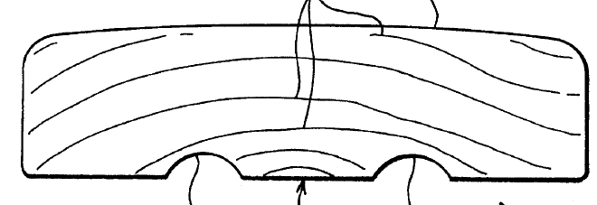

After ALL introduced its Plasti-Wood board, and began selling it, NAL found out that this was becoming a popular feature and may have been taking some sales away from NAL’s own deck planking products. So on July 25, 2001, NAL’s patent lawyers filed a request to reissue the ‘055 patent.

In the meantime, on September 17, 2002, NAL filed a patent infringement suit against ALL. It sought a preliminary injunction against ALL’s continued sale of curved PlastiWood planking for use in decks, as well as damages for patent infringement and willful infringement. The parties failed to settle and the case went to trial.

In preparing for the trial, ALL’s lawyers discovered several new pieces of prior art: a presentation by Canadian scientist Jacqui Robinson at the Finnish Society of Forresters (FSF), which was attended be researchers from all over the world, and a patent application by P.W. Reese, entitled “Curved Boards for Boat Docks,” filed on May 16, 1998 and published on January 7, 2000. The Reese application described rounded boards for the top of boat docks, to prevent water buildup and increase longevity. It said that the boards should be “round or curved, but not to steep, as that would be uncomfortable (especially as many people walk on boat docks in bare feet.”) The Reese application never became an issued patent, so the lawyers contacted Reese to find out what had happened. Reese said that he was a carpenter who had been working on boat docks for over thirty years. He said that he had conceived of his invention while refurbishing a dock at a summer camp in June of 1997, and written down his ideas on a tablecloth at a local bar. It so happened that the tablecloth was also as a sort of “birthday card” for the bar’s owner; regulars in the bar had written birthday wishes on the tablecloth, and it had been displayed behind the bar ever since. Reese said that he built the first actual dock with top-rounded boards in January, 1998. He said he had abandoned the application in June, 2000, shortly after it was published, when he ran out of money to pursue it.

In her presentation to the Finnish Society of Foresters (FSF) on January 7, 1998, Jacqui Robinson explained her research concerning the optimal use of wood from cut timber. She explained that prior research had shown the benefits of using wood in its “natural configuration,” i.e., with the outer or “bark side” side of cut wood turned in the direction expected to receive the most wear. She used the following diagram to explain her technique for computer-aided wood cutting:

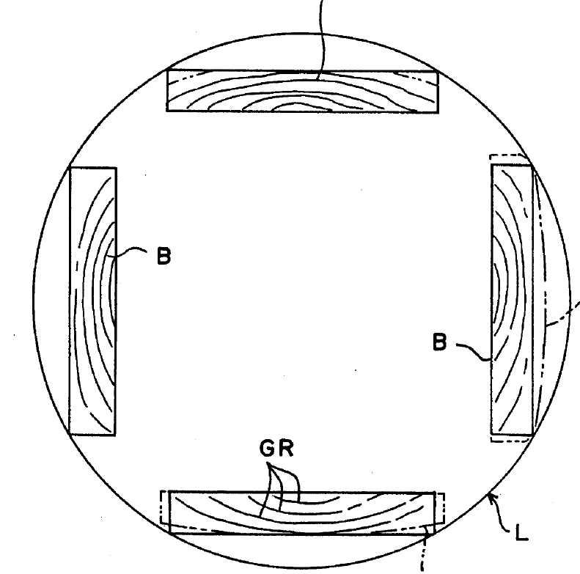

Notice in the diagram that the program calculates first how to cut the maximum number of pieces of wood with the correct configuration (bark side out) from a given log. Robinson included in her presentation a PowerPoint slide stating that “the program can be set to calculate the maximum of ‘natural configuration’ [i.e., bark side out] boards with flat tops and bottoms. In addition, because the algorithm is not limited to strictly flat wood products, it can also calculate maximums for boards with curved surfaces (which may be desirable, especially in combination with the higher strength of ‘natural configuration’ boards, for flooring, planking, and other applications where comfort and weather exposure are combined).” Some attendees at the conference were mistakenly sent emails containing this presentation, though Jacqui had not authorized this. In addition, Jacqui made the same presentation to the Forestry Department at the University of Oregon on October 31, 1997. The presentation was made available on a website run by the Department for one day only, so that interested members of the audience could see the slides on their own computers. But Jacqui expressly required all attendees who had downloaded the presentation to delete it. It was removed from the website after her presentation.

ALL’s lawyers learned about Jacqui’s presentation from other people who were present. They were also told that Jacqui had mentioned building various structures out of curved boards made using her log-cutting computer program. But when they contacted her, she said she could not speak to ALL about these matters because she had been contacted by NAL’s attorneys a few weeks earlier and had agreed to serve as an expert for NAL, assisting the NAL legal team in evaluating potential prior art and other issues. She said that she had signed a confidentiality and nondisclosure agreement concerning her involvement in the case, and that she could not speak to NAL’s lawyers about any prior art she had evaluated – even her own.

In studying the Zimmer paving stone reference, ALL’s lawyers made a discovery. The drawing of the paving stone (reproduced above) is described in the patent specification as “accurate and to scale.” ALL’s legal team measured the dimensions of the paving stone illustrated in this figure, and found that (after adjusting for the scale) the width of the stone as pictured was 50 inches, and the radius of curvature was 260 inches.

The ALL lawyers also discovered that NAL requires some of its authorized dealers and distributors to sign a licensing agreement before being permitted to resell planking covered by the ‘055 patent. As part of the agreement, the distributors agreed not to carry or sell a certain brand of deck stain and waterproofing, called Drysdale Deckstain. NAL claimed that Drysdale Deckstain did not work well with its planking, but ALL suspected that the real reason was so NAL could sell more of its own brand of deckstain.

In preparing for trial, NAL’s lawyers have identified an expert witness who is willing to testify that in the construction industry, “board” can mean planking made of wood or any other suitable material. After looking through a dozen technical and general purpose dictionaries, they have also identified two entries in which the definition of “board” is not limited to wood. ALL’s lawyers have found numerous dictionary definitions of “board” that do limit it to wood, however.

Lawyers for NAL claim they have economic evidence, derived from experts, that shows that NAL’s customers valued the high-comfort feature of the SC team’s curved boards enough that they would have paid a 10% premium over the “going rate” for standard decking boards of $3.00 per foot of 5 x 4 decking board. In addition, they argue that the rain-shedding feature of the boards would extend the life of any deck built with them by 20%. (This, they argue, is equivalent to a 20% cost saving for a deck.) Thus together, they argue that these factors mean that NAL could have charged 30% more for its decking boards than standard decking boards.

The actual data show that NAL’s and ALL’s boards sold for an average price of $3.10 per board foot. During the relevant period (July, 1999, until November, 2002), NAL actually sold 900,000 board feet of decking boards, and ALL sold 600,000 board feet of its Plasti-Wood boards, plus an additional 400,000 of conventional wooden boards made to the Pasti-Wood dimensions (i.e., with the same radius of curvature of the Plasti-Wood boards). After NAL received the preliminary injunction in November, 2002, ALL reconfigured its production equipment and in April, 2003, began selling conventional boards that were still curved, but were much flatter (i.e., with a radius of curvature of 36 inches or so).

Questions:

What will the result be in the NAL v. ALL litigation? Be sure to discuss both validity and infringement, and any other issues that are relevant. Feel free to be creative!

What damages should NAL receive if it wins the infringement suit?

Predict the fate of NAL’s reissue request for the ‘055 patent. Assuming the patent is reissued, what arguments might ALL have if NAL asserts the reissued patent in the NAL/ALL litigation? What alternative to reissue might NAL have pursued instead?

Bonus Issue

What public policy issues are implicated by Jacqui Robinson’s employment by the NAL legal team? How would you handle that issue, and the broader question of the Robinson prior art, if you were the judge in the case?

